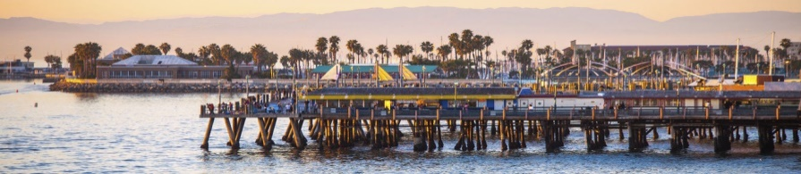

Redondo Beach Police Foundation (RBPF)

Corporate Partner Program

Membership Levels
Champion Level - $50,000 | ** Reach out to our Executive Director for more information**
Chief Level - $25,000 | - One-on-One Lunch with the Chief with up to four attendees  - 6 Tickets to Annual Meet the Chiefs Fundraiser (or other annual event)  - 4 Premier Tickets to any home game for the Los Angeles Kings  - Invitation to Business/Police Networking events  - Featured donor in Annual Report  - 10 Foundation Tumblers for your staff  - Appreciation Plaque to display at your company or in your office  - Logo on Foundation Website for one year  - Ride-a-long with K9 or patrol unit for the day
Deputy Chief Level - $10,000 | - 2 Tickets to Annual Meet the Chiefs Fundraiser (or other annual event)  - 2 Premier Tickets to any home game for the Los Angeles Kings  - Invitation to Business/Police Networking events  - Recognition in the Foundation’s Newsletter  - Featured donor in Annual Report  - 10 Foundation Tumblers for your staff  - Appreciation Plaque to display at your company Logo on Foundation Website for one year
Captain Level - $5,000 | - Recognition in the Foundation’s Newsletter  - 2 Tickets to Annual RBPF Event  - Invitation to Business/Police Networking events  - Featured in annual report  - Appreciation sticker for business  - 5 Foundation Tumblers and Window Decal for business  - Appreciation Plaque to display at your company  - Logo on Foundation website for one year
Lieutenant Membership - $2,500 | - Window Decal for business with Foundation Member logo  - Invitation to Business/Police Networking events throughout year  - One ticket to annual RBPF Event  - One Foundation Membership Tumbler  - RBPD Foundation Window decal  - Logo on Foundation Website for one year  - Recognition in Annual Report  - Appreciation certificate to display at your company
Sergeant Membership Level - $1000 | - Appreciation sticker for business with Member logo  - Appreciation certificate to display at your company  - RBPD Foundation car decal  - Recognition in the Annual Report  - Logo on RBPF Website
Officer Sponsorship Level - $500 | - RBPD Foundation window decal  - Name on RBPF Website  - Recognition in the Annual Report  - Appreciation certificate to display at your company or in your office signed by Police Chief
For more information, please contact Robin Garfield, Executive Director at Robin@redondobeachpolicefoundation.org

